**Storyboard**

Narrative

Act I : Vincent’s Dream

In a dream, the goddess, Salus, warns Vincentius that Pompeii is in danger. She sends him on a journey to the top of Mount Vesuvius to save Pompeii.

Vincentius wakes up, and sneaks off from his Barracks to begin his journey up Mount Vesuvius.

Vincentius begins faces his first trial – the woods leading up to the mountain. He is guided by Salus via stone tablets.

Act II: Apollo and the Gap

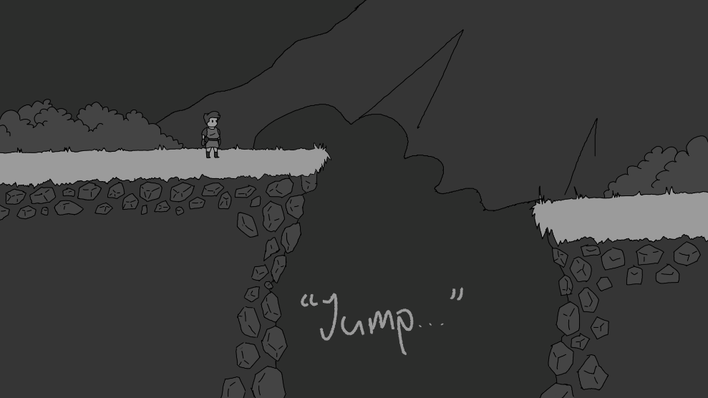After overcoming the challenges under Salus’s guidance, Vincentius is faced to jump over a large valley. A mysterious voice whispers to him, “Jump, my child.”

Vincentius takes the leap, and as he is falling. The same voice, which is Apollos’ voice, blesses him with his bow, which grants Vincentius the ability to launch himself midair. He uses this newfound ability to cross the valley.

Act III: Wildlife and Fire

Vincentius continues his journey up the mountain, and eventually stumbles upon a statue of Feronia, the goddess of Wildlife.

Vincentius reads the statue, and the voice of Feronia begins to speak to him. She explains that Mount Vesuvius is going to erupt, and that Vulcan, the god of fire was the reason for the eruption.

Feronia tells Vincentius to reach the top of the Mountain, and to convince Vulcan to not to erupt Mount Vesuvius. She grants you her blessing, and Vincentius carries on.

Act IV: War and Peace

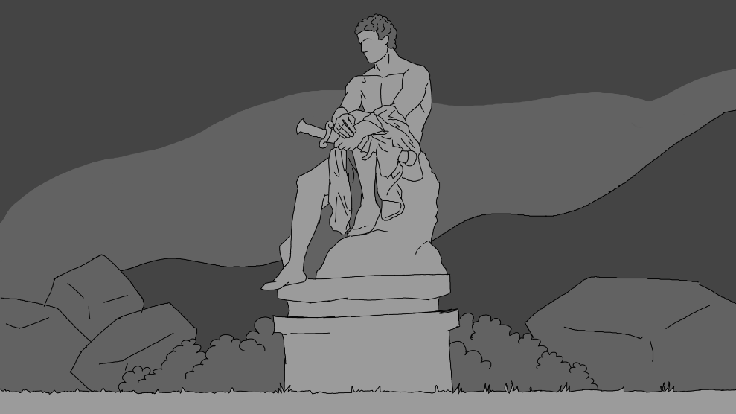

Vincentius eventually stumbles upon a statue of Mars, the god of War.

Vincentius reads the statue, and similar to Feronia, Mars begins to speak to him. Mars explains to Vincentius that the only way to stop the eruption is to kill Vulcan. Mars gives his blessing and Vincentius continues up the mountain.

Act V: A Fiery End

Vincentius reaches the peak of the mountain and meets Vulcan. He is frustrated.

Vincentius begins to speak to Vulcan, and Vulcan explains to Vincentius that he is frustrated with the people of Pompeii. He is jealous of Apollo, who is worshiped more than him. He wants people to remember him, and to worship him once more.

Vincentius is prompted with three choices: to convince Vulcan there are better ways to fix his problem, to kill Vulcan, or allow Vulcan to continue his plans.

Convincing Vulcan will only prevent the eruption half the time, killing Vulcan will always prevent the eruption, and allowing Vulcan to continue his plans will always end in the eruption. The choice is up to the player.

**Storyboard**

Concept Art and Progression

Environment Concepts:

This image, created early on in the project, was the visual goal we had for the game. It standardized the uses of some colors on the color palette, as well as the shape of trees, rocks and bushes. Without this mockup, the game would not look nearly as cohesive.

To the left is the first depiction of Mount Vesuvius, which became the basis to how the mountain was drawn in latter development.

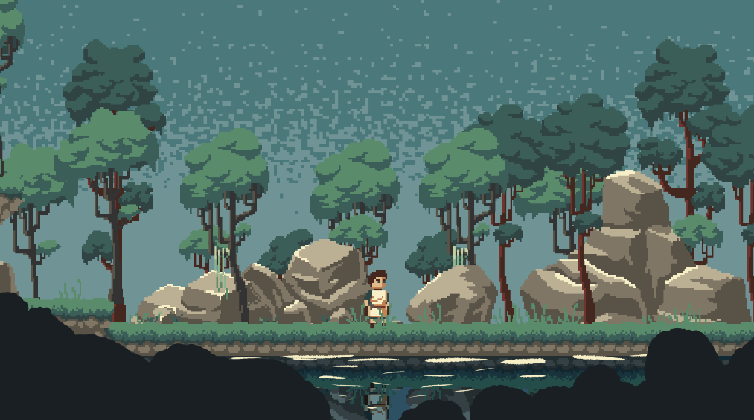Below is the first draft of the bush silhouettes in the foreground.

Player Concepts:

The player character underwent a multitude of changes throughout the project.

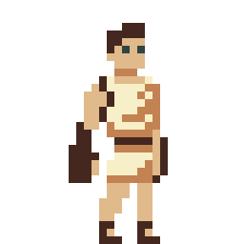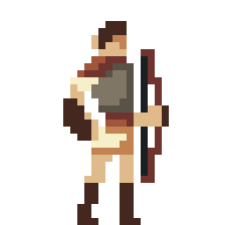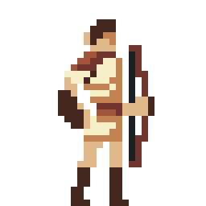

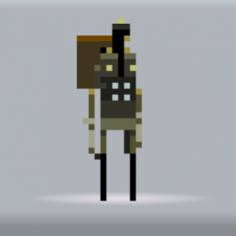These first, lankier designs were inspired by games such as Superbrothers: Swords and Sworcery.

However, animation on these lanky designs left much to be desired.

It was hard to add any character to the animations without making the sprites impossible to interpret. For this reason, we redesigned the character to be larger, which made the character much easier to animate.